Bringing in An Effect from CapCut

CapCut
In this tutorial, we will be looking at another video editing app, which we can use to help us create some effects in DaVinci.

CapCut is a free video editing program that you can also get on the web.
CapCut Download

PART 1 — CREATE THE EFFECT IN CAPCUT
- Open CapCut
- Create a new project
Create a black background in something like photoshop, and then just slide it in
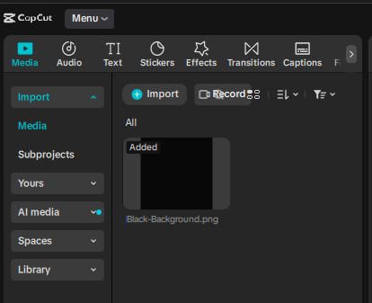
Add the black background to the timeline at the bottom of the app
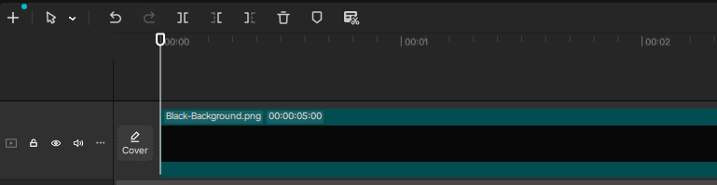
Go to the top of the app, and click on the tab that says Effects.
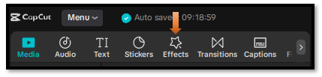
Do a search for glitter fall and hit enter, to have a list of glitter effects show up. I will be using the first effect.
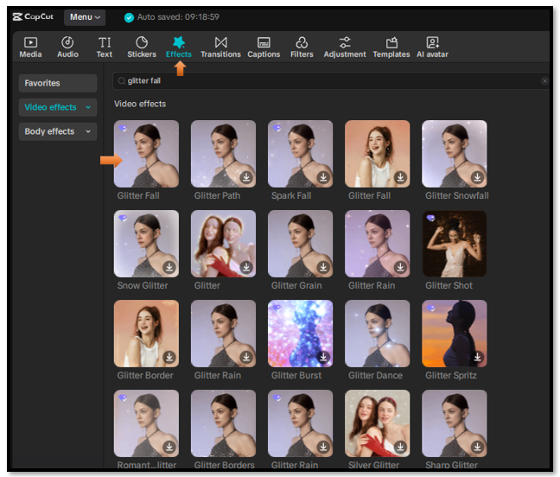
Add your effect ONLY
- Drop in the “glitter fall” effect. (Drag it to the track above the background)
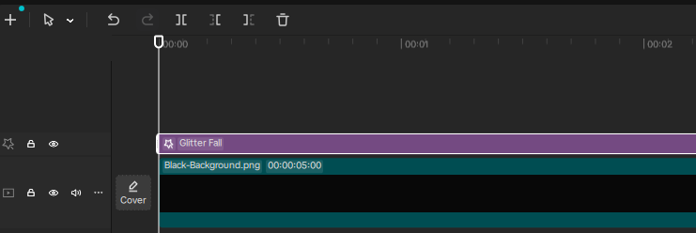
Two of the most important things when creating this effect.
- Make background BLACK
- Make glitter bright (white or warm)
Export Effect Video
Go to the top left side and click on Export.

Fill in the form here, and then hit the teal export button at the bottom
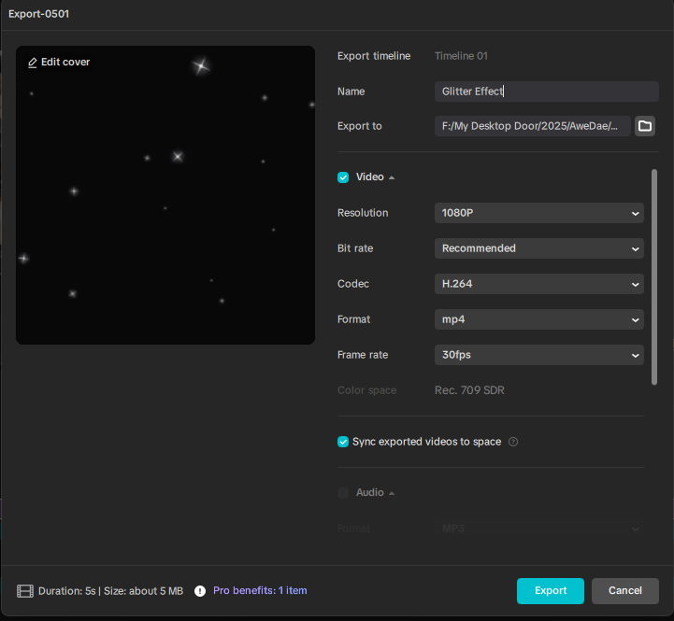

DaVinci
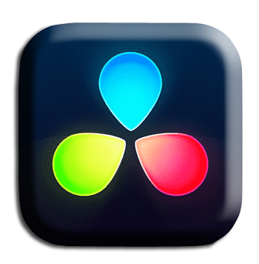
Ok, now we need to drag this effect into our DaVinci app.
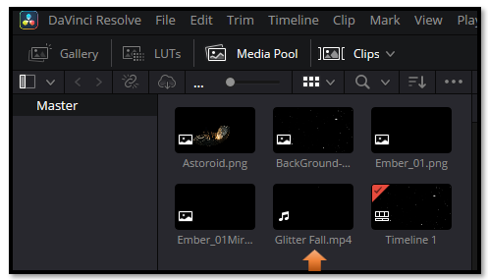

Drag it down on the Timeline
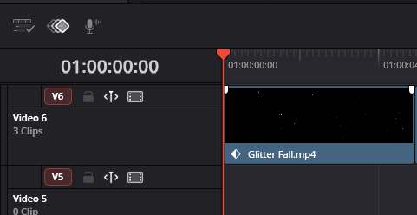

Color Tab
Click on the Color tab at the bottom to go to the Color page

Make sure you have the right clip selected
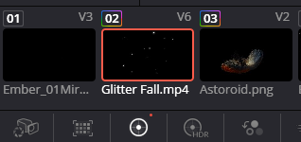

How to Blend our Shadows into the black for Transparency
Effects come in with an off black, and we need to blend that in, and get it to be black in order to get transparency.
In Color Page (on the glitter clip):
Hit Alt-S to add a node
Alt-S
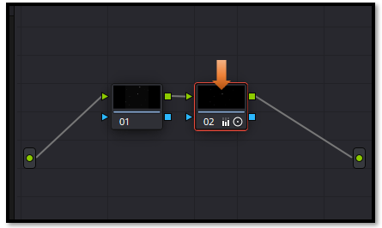
- Lower Lift (shadows)
👉 pull it down until background disappears
- Increase Contrast slightly
- Adjust Gamma carefully
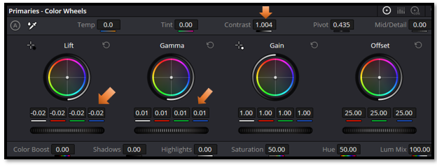

Go back to the Edit Page.


In the inspector on the right hand side, Turn down the opacity, just a tad bit.
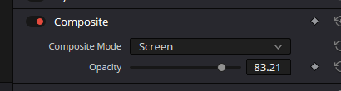

You should see the Glitter effect blend into the black background

